Title : Signal Processing

Course: E&EE Final Year

Date: 23_03_2001

A low pass analogue filter is required to have a 3dB cut off at 2kHz and 40dB per decade roll-off.

- ABSTRACT

Two methods of filter design have been studied and justified using MATLAB. The first requires the designer to evaluate through trial and error the location of poles and zeros on the s-plane. The Frequency response is evaluated in each case. Once the response is correct to the specification the system transfer function can then be taken directly from the pole zero map. The second approach relies on Classical filter prototype design investigation. Using common filter prototypes such as the Butterworth, Chebyshev and elliptic, the designer can select a response and by using standard tables create the system transfer function. The effectiveness of both approaches are compared and contrasted in the latter stages of the report.

- INTRODUCTION

RESULTS/DISCUSSIONS OF RESULTS

Part 1 – Arbitrary pole and zero placement on the s-plane

i). Choose a pair of poles

To achieve a roll-off equal to 40dB per decade a 2nd order filter is required i.e. one which has two poles in it’s polynomial transfer function.
The low pass filter is required to pass frequencies below 2kHz, which is equivalent to the radian frequency calculated below.

ω = 2 x pi x f = 2 x 3.14 x 2x10³ = 12.566 x 10³ rads⁻¹

So as a starting point a pair of conjugate poles placed at +- the radian cut off frequency will be placed on the jω axis.

ii). Evaluating H(jω) for this pair of conjugate poles

Shown in Figure(1.1) is a pole zero map of the initial transfer function. The symbolic poles are very faint, but on close inspection they occur at +-12566 on the jω axis. This map is created in MATLAB using the following command:-
MATLAB SCRIPT 1.1

z=[];
p=[+12566j, -12566j];
k=1;
[num, den]=zp2tf(z, p, k);
pzmap(num, den)

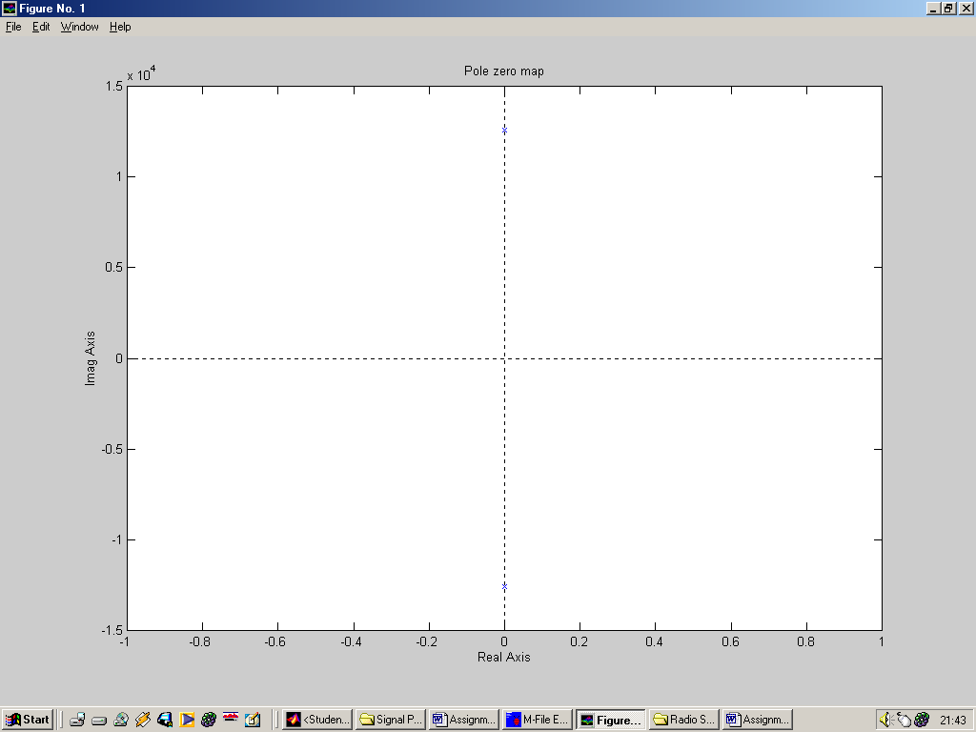

Figure(1.1) A pair of conjugate poles at +-12.566 x 10³ on the jω axis

The transfer function H(jω) will be constructed graphically from the pole zero plots. The transfer function will be evaluated from 0.5 rads⁻¹ to 1 x 10⁴ rads⁻¹ in steps of 0.5 x 10^{n+1} rads⁻¹.
Initially the frequency response of the filter will be evaluated at a radian frequency ω of 0.5 rads⁻¹. The distance from each of the poles (B₁, B₂) to the specified ω value are then calculated.

ω = 0.5 rads⁻¹
B1
B2
ω_{c} = 12566 rads⁻¹

Figure(1.2) Geometric construction for determining amplitude response of the low pass filter

Looking at Figure (1.2),
the distance B1 (from the pole to the chosen ω value) is:-
B1 = 12.566 x 10³ – 0.5 = 12.565

the distance B2 (from the pole to the chosen ω value) is:-
B2 = 12.566 x 10³ + 0.5 = 12.567

Using the equation below to solve the frequency response we have:-
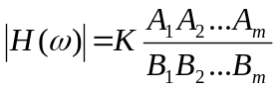

where A is the distance from the chosen ω to the zeros and B is the distance from the chosen ω to the poles. The phase response will be evaluated later.
Because there are no zeros in the chosen transfer function, the numerator of the frequency response becomes 1. K is also assumed to be 1, i.e. no amplification is present in this system.

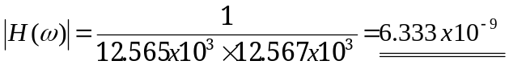

Note: H(ω) is a ratio, hence has no units.

Now the procedure for finding the amplitude of a system is known the amplitude response of a system can be tabulated for a given value of ω.

ω (rads⁻¹) | H(ω)
0.5 | 6.333x10⁻⁹
1.0 | 6.333x10⁻⁹
5.0 | 6.333x10⁻⁹
10.0 | 6.333x10⁻⁹
50.0 | 6.333x10⁻⁹
100.0 | 6.333x10⁻⁹
500.0 | 6.343x10⁻⁹
1000.0 | 6.373x10⁻⁹
5000.0 | 7.524x10⁻⁹
10000.0 | 1.727x10⁻⁸
12566.0 – cut off frequency | infinity
20000.0 | 4.131x10⁻⁹
50000.0 | 4.270x10⁻¹⁰
100000.0 | 1.016x10⁻¹⁰

These values, if plotted on log-log graph paper would look similar to that shown below.

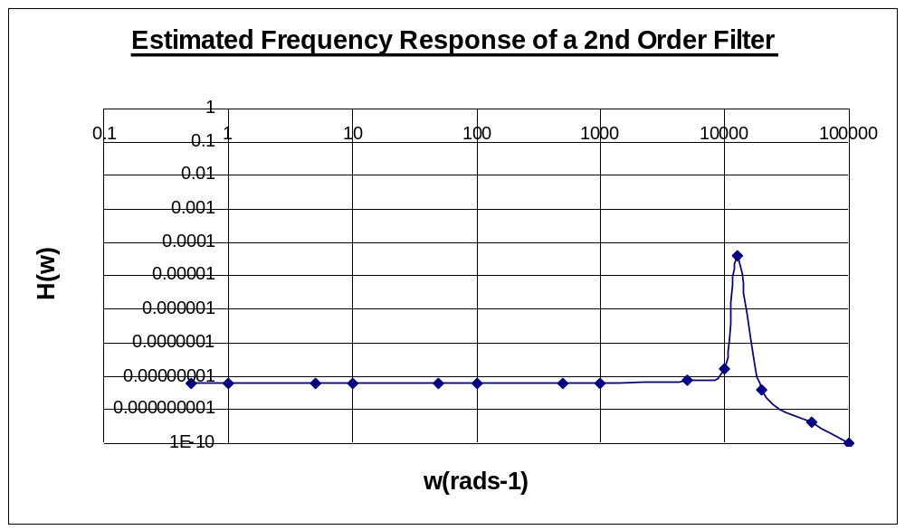
Figure(1.3) Estimated frequency response of the 2nd order low pass test filter

In Figure(1.3) it can be seen that the filter has a nice flat response at approximately 1x10⁻⁸ at radian frequencies up to 10kHz. At this point the output amplitude increases dramatically up to it’s maximum amplitude of approximately 5x10⁻⁵ (which is supposed to indicate infinity) at 12kHz (the resonant frequency). The amplitude response then tails off at a fast constant rate up to a frequency of approximately 20kHz. After this point the response tails off at a constant rate 10^{n-1} per decade.

Shown below is a MATLAB script and results for the given transfer function specified above.
MATLAB SCRIPT 1.2

z=[];
p=[+12566j, -12566j];
k=1;
[num, den]=zp2tf(z, p, k);
Freqs(num,den);

The resultant frequency response can be observed in Figure(1.4)

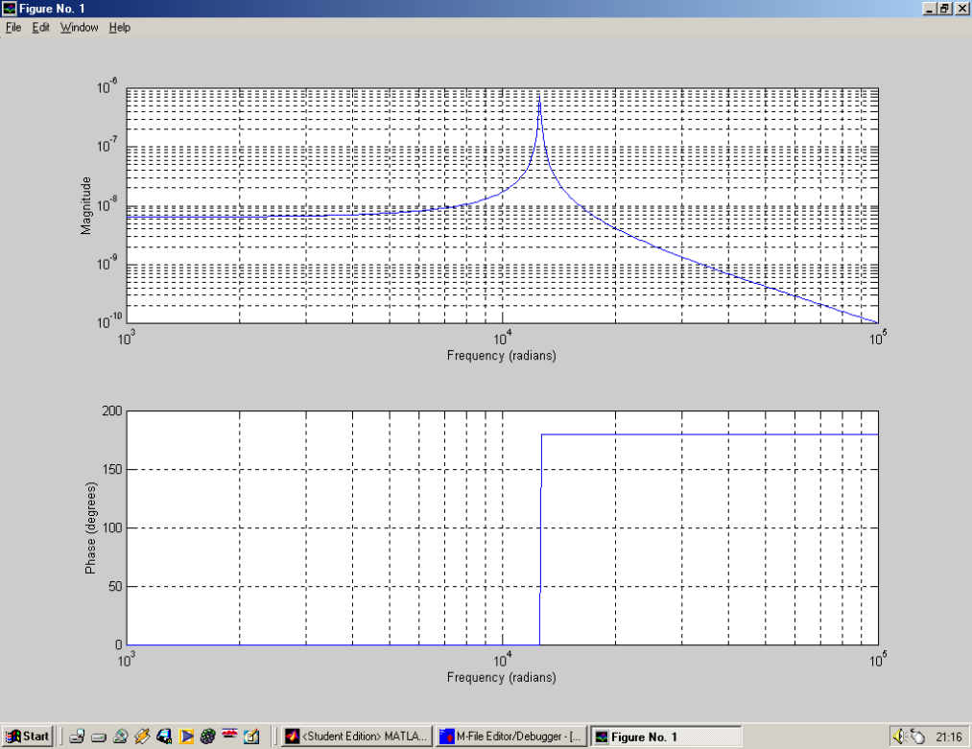

Figure(1.4) Actual frequency response of the 2nd order system using MATLAB

Figure 1.3 compares faithfully to Figure 1.4 in many respects. The graphical estimate reproduces the shape but magnitudes of the amplitude response are not so faithfully reproduced. In any case, looking soley at the MATLAB response, it can be seen that a frequency of 2kHz is not filtered out by the system.

iii) Adjusting by trial and error the location of the location of the poles until the frequency response is as required

Revision 1

In Figure(1.4) it can be seen that the maxima amplitude response occurs at the specified cut off frequency which also is the magnitude of one of the conjugate poles. To cut out a frequency of 2kHz, the previous responses maxima requires shifting to the left so it occurs at approximately 9000 rad/s. When the poles of the system are now placed at +- j9000, the frequency of 2kHz should be filtered out. Again repeating steps I) and ii).

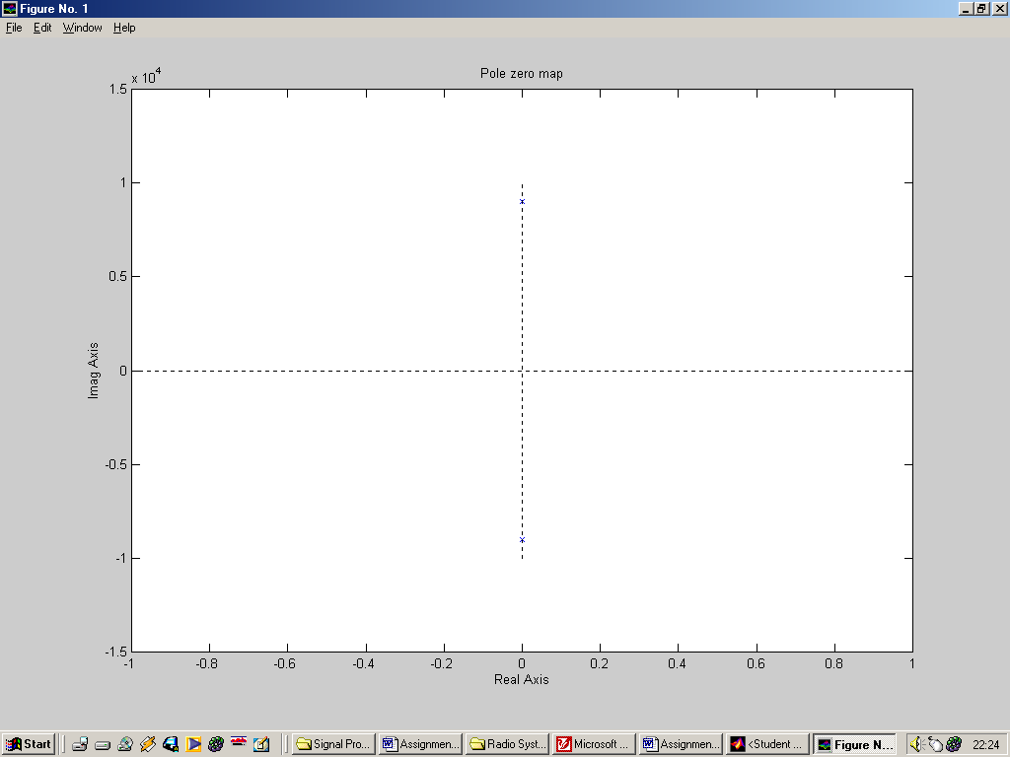
ω = 0.5 rads⁻¹
B1
B2
ω_{c} = 12566 rads⁻¹

Figure(1.5) Revised Geometric construction for determining amplitude response of the low pass filter

Looking at Figure(1.5),
the distance B1 (from the pole to the chosen ω value) is:-
B1 = 9 x 10³ – 0.5 = 8999

the distance B2 (from the pole to the chosen ω value) is:-
B2 = 9 x 10³ + 0.5 = 9001

Using the equation below to solve the frequency response we have:-
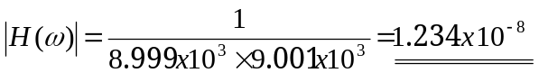

Using the same procedure, the amplitude response of a system can be tabulated for a given value of ω.

ω (rads⁻¹) | H(ω)
0.5 | 1.234x10⁻⁸
1.0 | 1.234x10⁻⁸
5.0 | 1.235x10⁻⁸
10.0 | 1.235x10⁻⁸
50.0 | 1.235x10⁻⁸
100.0 | 1.235x10⁻⁸
500.0 | 1.238x10⁻⁸
1000.0 | 1.205x10⁻⁸
2000.0 | 1.299x10⁻⁸
5000.0 | 1.786x10⁻⁸
9000.0 | infinity
10000.0 | 5.26x10⁻⁸
500000.0 | 4.134x10⁻¹⁰

These values, if plotted on log-log graph paper would look similar to that shown below.

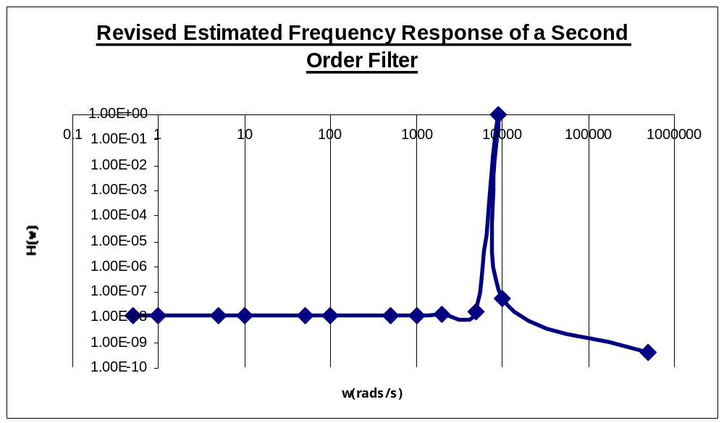
Figure(1.6) Revised estimated frequency response of the 2nd order low pass test filter

In Figure(1.6) it can be seen that the filter has a nice flat response at approximately 1x10⁻⁸ at radian frequencies up to 7000 rad/s. At this point the output amplitude increases dramatically up to it’s maximum amplitude of 1, which is a representation of infinity (the resonant frequency). The amplitude response then tails off at a fast constant rate of 10^{n-1} radians per decade.

Shown below is a MATLAB script and results for the given transfer function specified above.

MATLAB SCRIPT 1.2

z=[];
p=[+9000j, -9000j];
k=1;
[num, den]=zp2tf(z, p, k);
Freqs(num,den);

The resultant frequency response can be observed in Figure(1.7)

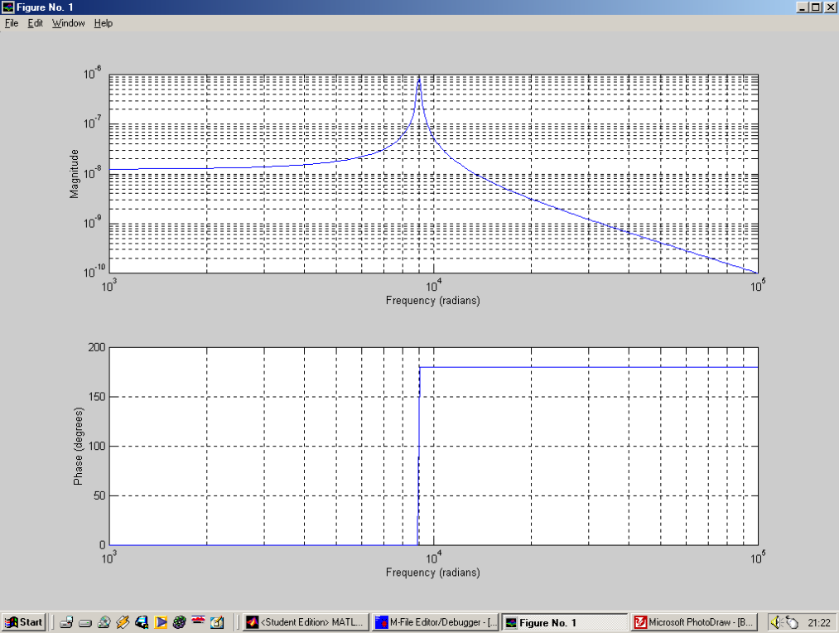

Figure (1.7) Actual revision 1 frequency response of the 2nd order system using MATLAB

Again the graphical amplitude response is faithful to that of the MATLAB revised response. The cut off frequency has got to be 3dB’s down from the pass band. So lets now look at the Matlab Bode Plot Amplitude Response, the Bode plot will give the amplitude response in dB’s.

MATLAB SCRIPT 1.3

z=[];
p=[+9000j, -9000j];
k=1;
[num, den]=zp2tf(z, p, k);
Bode(num,den);

The resultant frequency response can be observed in Figure(1.8)

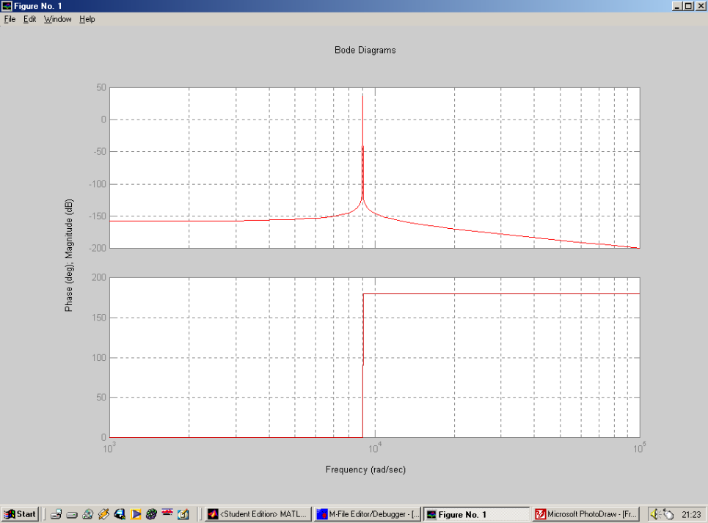

Figure(1.8) Bode Plot of 2nd order system response using MATLAB

In Figure(1.8) it can be seen that frequencies above approximately 1.5x10⁻⁴ rad/s are filtered out i.e. these frequencies are 3dB down from that of the steady state pass band magnitude. Seeing as this is approximating method the values of the poles used are correct to an extent. At the present moment in time the poles are placed on the jω axis, there is no real part to the poles used. Taking some time to take in what has happened to the frequency response for the previous values of the poles. It can be seen that when ω is varied, and when ω is equal in magnitude to the pole on the jω axis, the amplitude response shoots off to infinity. Hence the observed resonant peak visible in Figures(1.4), (1.7) and (1.8). Now to be rid of the resonant peak the conjugate poles require a sigma value. Taking into consideration the Nyquist stability criterion, i.e. The system is stable if all the poles lie in the left hand s-plane. The poles therefore must have negative real parts, how large the real parts must be is up to me the designer.

Revision 2

Many sigma values have been evaluated (the frequency response results of these can be found in the appendix of this report), if the sigma value is the same magnitude as the imaginary component i.e. –9000 the resultant frequency response graph is found to be correct. Hence this revision of the low pass filter system will have poles at a sigma value of -9000. This should in theory cause the resonant peak to flatten completely as evaluated.

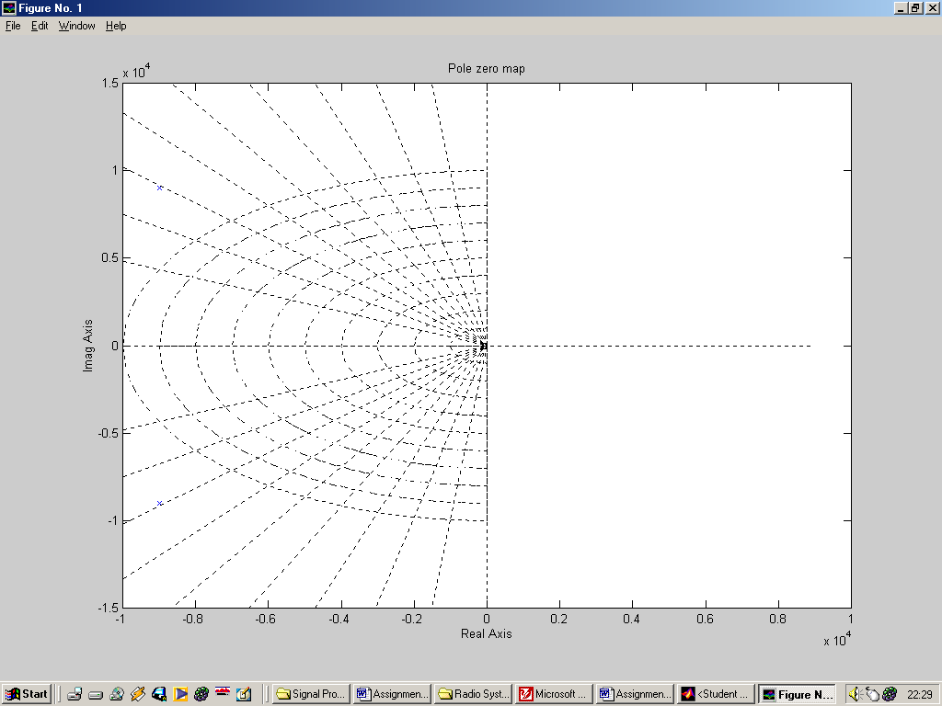
ω = 0.5 rads⁻¹
B1
B2
ω_{c} = 12566 rads⁻¹

Figure(1.9) Revision 2, Geometric construction for determining amplitude response of the low pass filter

Looking at Figure(1.8),
the distance B1 (from the pole to the chosen ω value) is:-
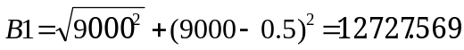

the distance B2 (from the pole to the chosen ω value) is:-
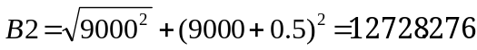

Using the equation below to solve the frequency response we have:-
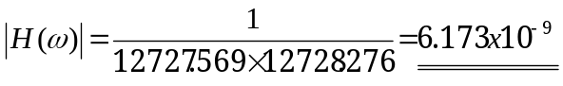

Using the same procedure, the amplitude response of a system can be tabulated for a given value of ω.

ω (rads⁻¹) | H(ω)
0.5 | 6.173x10⁻⁹
1.0 | 6.173x10⁻⁹
5.0 | 6.174x10⁻⁹
10.0 | 6.173x10⁻⁹
50.0 | 6.139x10⁻⁹
100.0 | 6.173x10⁻⁹
500.0 | 6.173x10⁻⁹
1000.0 | 6.173x10⁻⁹
2000.0 | 6.171x10⁻⁹
5000.0 | 6.422x10⁻⁹
9000.0 | 5.521x10⁻⁹
10000.0 | 5.253x10⁻⁹
50000.0 | 3.992x10⁻¹⁰

These values, if plotted on log-log graph paper would look similar to that shown below.

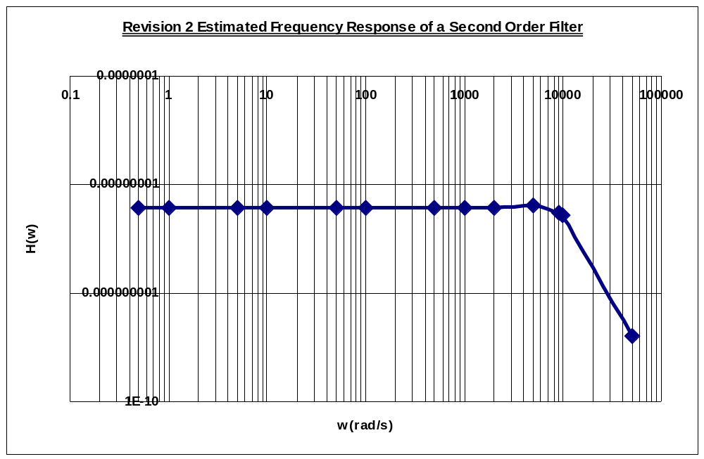 Figure(1.10) Revised estimated frequency response of the 2nd order low pass test filter

In Figure(1.9) it can be seen that the filter has a nice flat response at approximately 1x10⁻⁸ at radian frequencies up to 7000 rad/s. At this point the output amplitude increases dramatically up to it’s maximum amplitude of 1, this is supposed to representation of infinity (the resonant frequency). The amplitude response then tails off at a fast constant rate of 10^{n-1} radians per decade.

Shown below is a MATLAB script and results for the given transfer function specified above.

MATLAB SCRIPT 1.4

z=[];
p=[9000+9000j, 9000-9000j];
k=1;
[num, den]=zp2tf(z, p, k);
Bode(num,den);

The resultant frequency response can be observed in Figure(2.1)

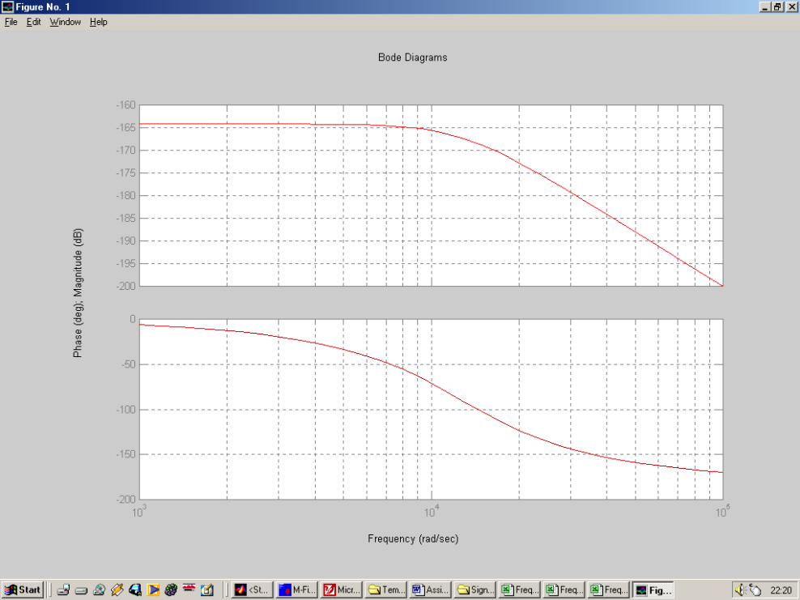

Figure(1.11) Bode Plot of 2nd order system response using MATLAB

Figure(1.11) shows the Bode plot for the 2nd and final revision of the low pass filter. The amplitude response is now correct. There is a nice flat pass band up to the corner frequency of approximately 10kHz. From this frequency onwards the amplitude response drops smoothly , at 3dB down from the pass band the frequency is approximately 13kHz. This matches the cut off frequency criteria stated in the Assignment question. The roll-off rate, is as stated 40dB per decade.

iv). Determining H(s) in polynomial form

H(s) can be simply determined directly from MATLAB SCRIPT 4. In the transfer function there are no zeros, the poles are at –9000+-j9000 hence:-

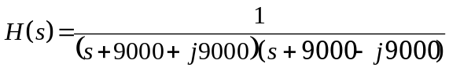

Multiply the denominator out we achieve:-

Gathering terms
Equation(1.1)
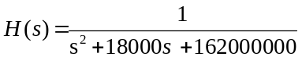

v). Computing Appropriate valuesof L, C to fulfil this design

The electrical circuit required to implement a second order passive low pass filter is shown in Figure(1.12). The derivation of it’s transfer function is also described.
R
L
C
V_{in}
V_{out}

Figure(1.12) Circuit configuration for a passive low pass filter

The transfer function for a 2nd order LC low pass filter network is

The transient governing circuit equations are:-

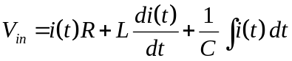
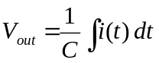

Taking the laplace transforms of both equations

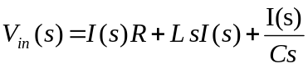
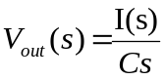
The transfer function of the network is just in this case the output voltage divided by the input voltage.

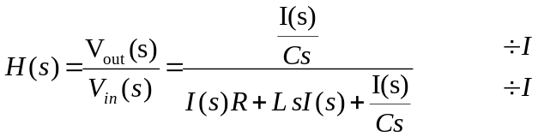

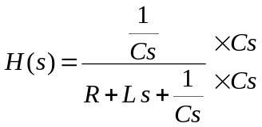

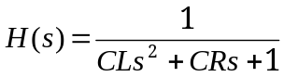

The transfer function as it stands is in the incorrect form, by dividing the numerator and denominator by the constant in front of the s

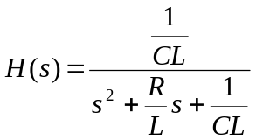
Equation(1.2)

Substituting values from Equation(1.1) into Equation(2.2), the values of L and C can be computed

CL = 1
CR = 1

Hence
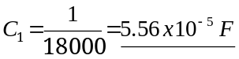

PART 2 – CLASSICAL FILTER DESIGN

i). Select an amplitude response for a low pass filter which is acceptable from those that exist, assuming the cut-off frequency will be 1 rad/s, (and for passive designs the source impedance is 1 ohm and the output impedance is 1 ohm).

The Butterworth filter

The Butterworth magnitude response for a normalised lowpass filter having a 1 rad/s cuttoff frequency is given by

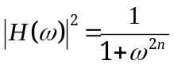
Equation(2.1)
where n is the order of the filter.

Given that a 40dB per decade roll off in magnitude is required above the cuttoff frequency a second order filter is required, hence n = 2 . Looking up the value for the order of the filter in Table(1.1), it can be seen that the transfer function for the low-pass prototype is:-

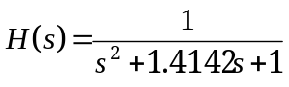
Equation(2.2)

Evaluating (Equation 2.1), for very small values of ω, the amplitude response of the Butterworth filter is a constant at a value of 1. Hence the flatness of the response in the passband. As ω is increased to the extent that ω^{2n} = 1, the amplitude response is halved i.e. 3dB down from the passband. And at higher frequencies the amplitude response is wholly governed by 1/ω⁴.

n
1 | (s+1)
2 | (s² +1.4142s + 1)
3 | (s+1)(s² + s + 1)
4 | (s² + 0.7654s + 1)(s² + 1.8478s + 1)
5 | (s+1)(s² + 0.6180s + 1)(s² + 1.6180s + 1)
6 | (s² +0.5176s + 1)(s² + 1.4142s + 1)(s² + 1.9319)
7 | (s+1)(s² + 0.4450s + 1)(s² + 1.2470s + 1)(s² + 1.8019s + 1)
8 | (s² +0.3902s + 1)(s² + 1.1111s + 1)(s² + 1.6629s + 1)(s² + 1.9616s + 1)
9 | (s+1)(s² + 0.3473s + 1)(s² + 1.0000s + 1)(s² + 1.5321s + 1)(s² + 1.8794s + 1)
10 | (s² + 0.3129s + 1)(s² + 0.9080s + 1)(s² + 1.4142s + 1)(s² + 1.7820s + 1)(s² + 1.9754s + 1)

Table(1.1) Butterworth Quadratics

ii) Transform this low-pass prototype into a low-pass filter with the appropriate bandwidth

Filter coefficients that appear in tables such as Table(1.1) are normalized for cutoff frequencies of 1 radian per second, or ω₀ = 1. Therefore, if these coefficients are used to generate a filter transfer function, the cutoff (or center) frequency of the transfer function will be at ω = 1. This is a convenient way to standardize filter coefficients and transfer functions. If this were not done,
different set of coefficients would be needed for every possible center fre-
quency. Instead, we use coefficients that are normalized for ω₀ = 1 because it is simple to rescale the frequency behavior of a 1 r.p.s. filter. In order to denormalize a transfer function each “s” term is replaced with s/ω₀ , where ω₀ is the desired cutoff frequency. Thus the second-order Butterworth low-pass function

could be denormalised to have the required cut-off frequency of 2kHz by replacing s with s/4000π as below:

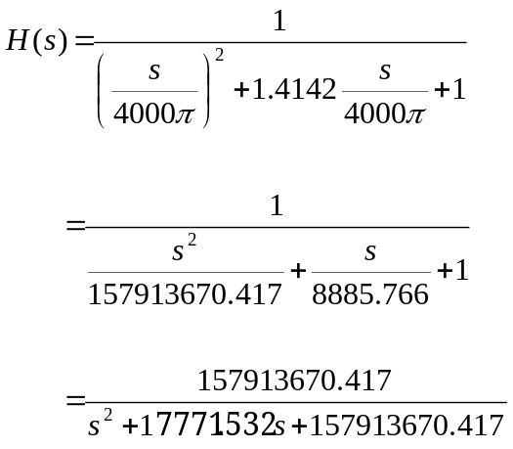

The frequency response can now be verified on MATLAB using the following commands.
MATLAB SCRIPT 2.1

num = [157913670.417]
den = [1 17771.532 157913670.417]
bode (num,den)

The resultant frequency response can be observed in Figure(2.1)

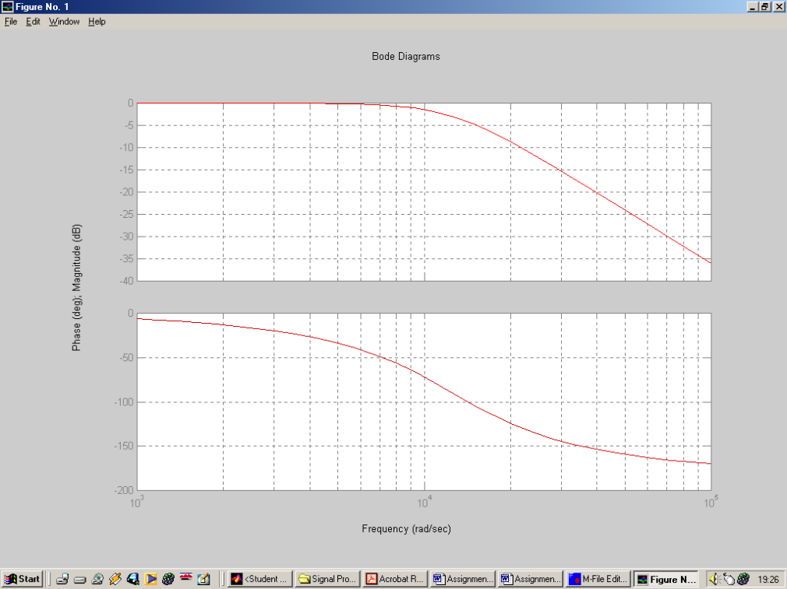

Figure(2.1) Bode Plot of the 2nd order Butterworth system response using MATLAB

Clearly the Bode plot of Figure(2.1) has the correct characteristics as stated in the design specification. The procedure used to denormalise the transfer function of Equation 2 into a user defined filter can be simply achieved in MATLAB by using the Butterworth command.

MATLAB SCRIPT 2.2

[num, den] = butter(2,[2000*2*pi],’s’)
bode (num,den)

By implementing MATLAB SCRIPT 2.2 the Bode Plot of Figure(2.1) is again achieved, hence the Butterworth command eradicates any need for lookup quadratic tables and denormalising.

Chebyshev I/II and Eliptical Filter

